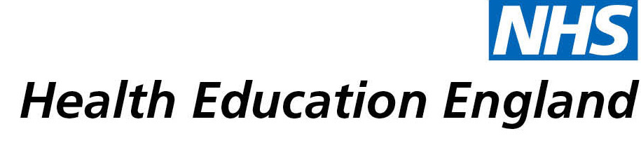

# Library and Knowledge Services case study

# Taunton and Somerset NHS Foundation Trust Library and Knowledge Services: Cost Improvement Programme Ideas

**Date: 21/05/2019**

## Reason for enquiry

The trust is responsible for making cost improvement savings. Each year the challenge becomes harder. We have undergone a large programme of work around cultural change and enabling colleagues to look for savings. We thought by giving colleagues some ideas around how to do this we could complement our existing effort and ideally spur things on.

## What the knowledge and library specialist did

We asked our Improvement Librarian to undergo a large piece of work which was to find cost improvement ideas from other national and international initiatives which related to each of the specialties across both Taunton and Somerset NHS Foundation Trust and Somerset Partnership. These were then passed onto the relevant Directorates to provide them with ideas and possible avenues to investigate and explore in relation to generating cost savings in their relevant specialties.

# Impact of input from the library and knowledge service

Helped our directorates think very differently about the cost improvement programme and the efficiency savings.

## Immediate Impact

“Contributed to enabling specialities to identify £20 million pounds of savings over the past 2 years.”

## Probable future Impact

Not supplied

## Submission by:

Lorna Stewart, Senior Improvement Team Lead and Clinical Psychologist, Taunton and Somerset NHS Foundation Trust

## For further information on how you can get similar support contact your local NHS library and knowledge service.